**Assignment 1** CH5440: Multivariate data analytics for process modelling

**Devendra ME15B099**

**………………………………………………………………………………………………………………………..**

**Ans 1)**

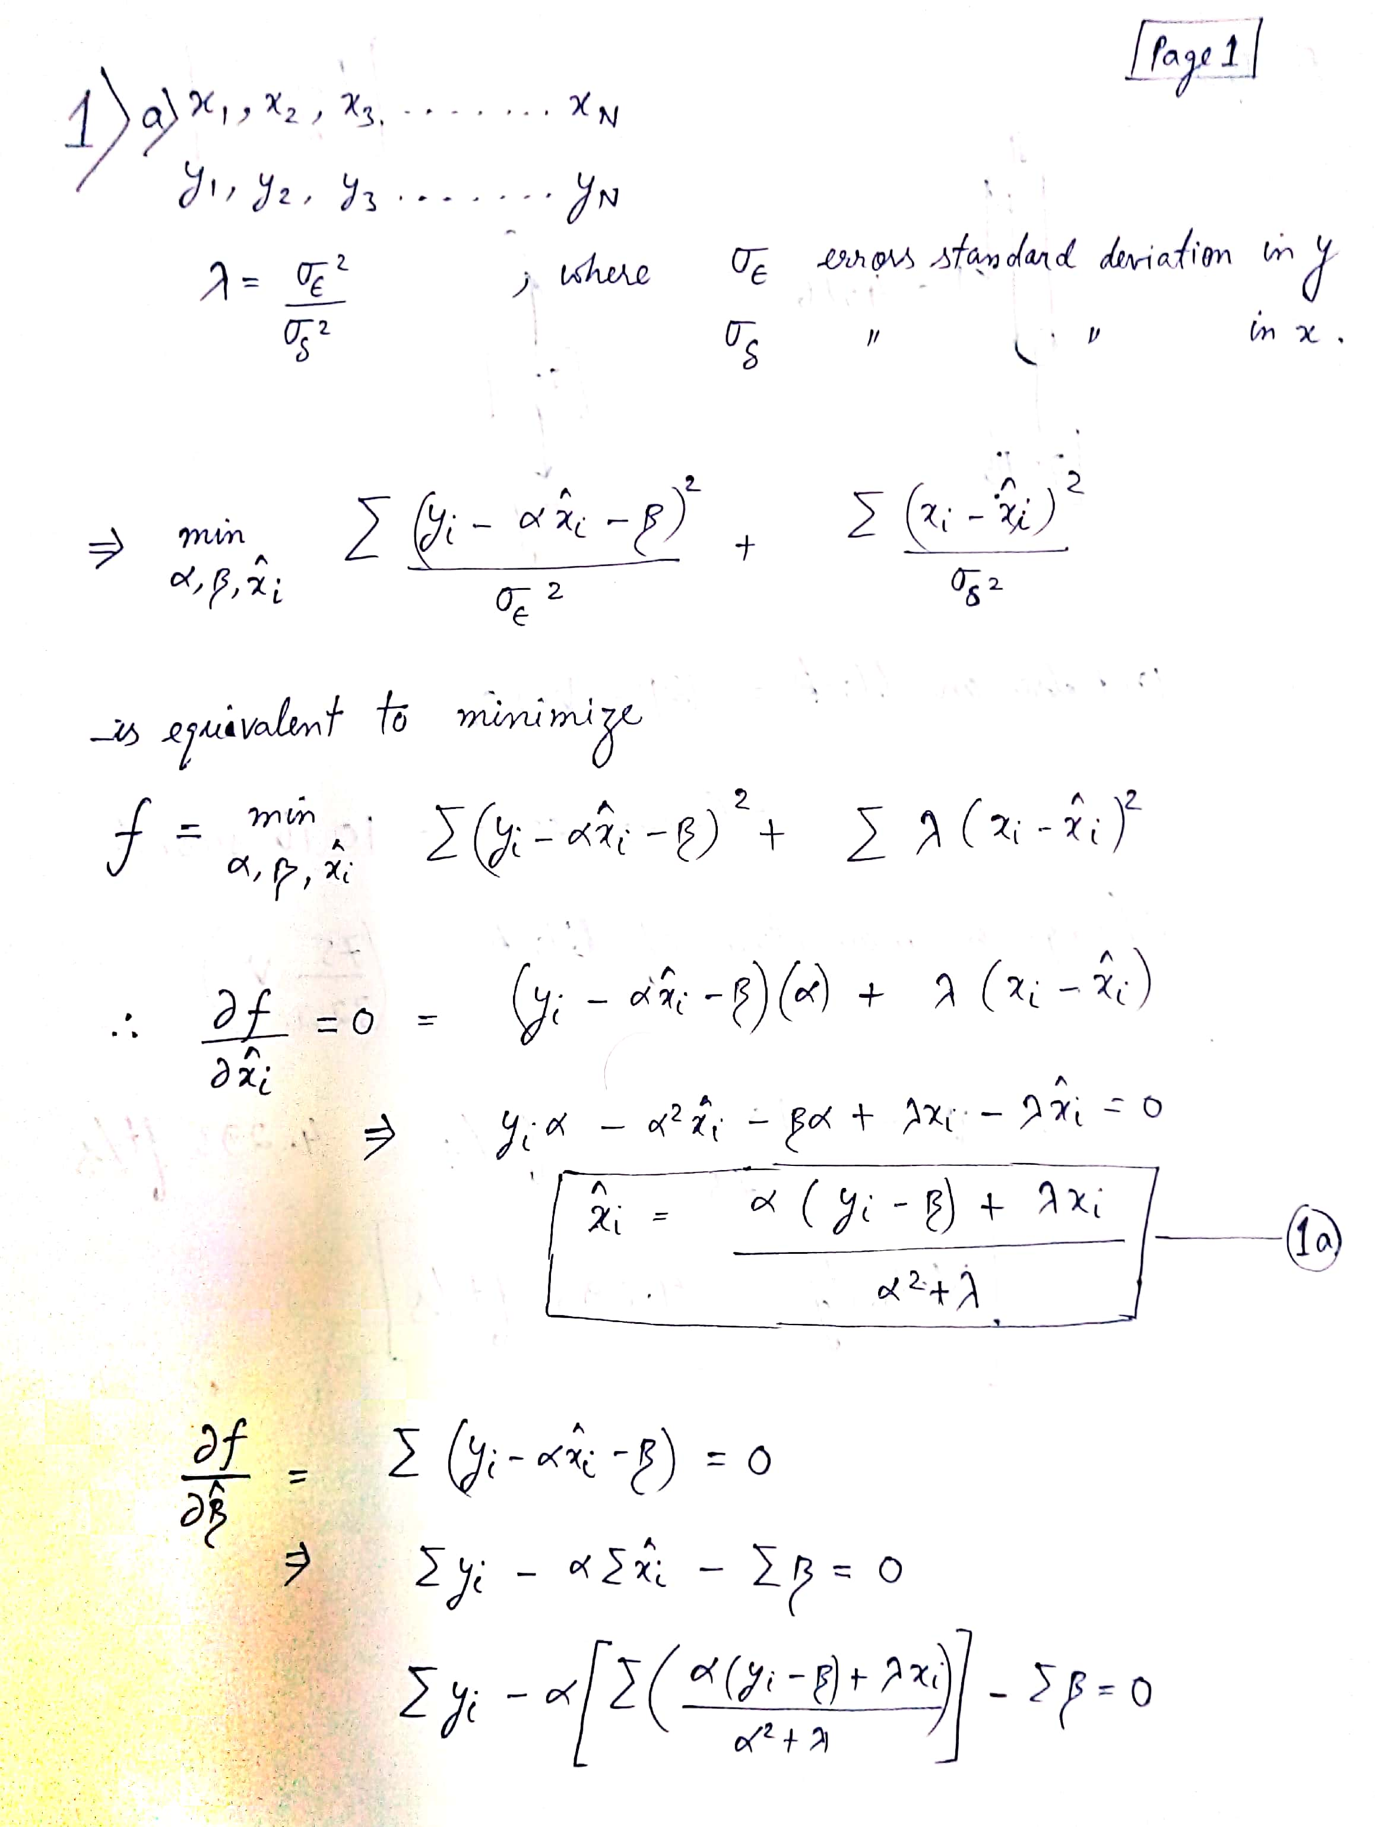

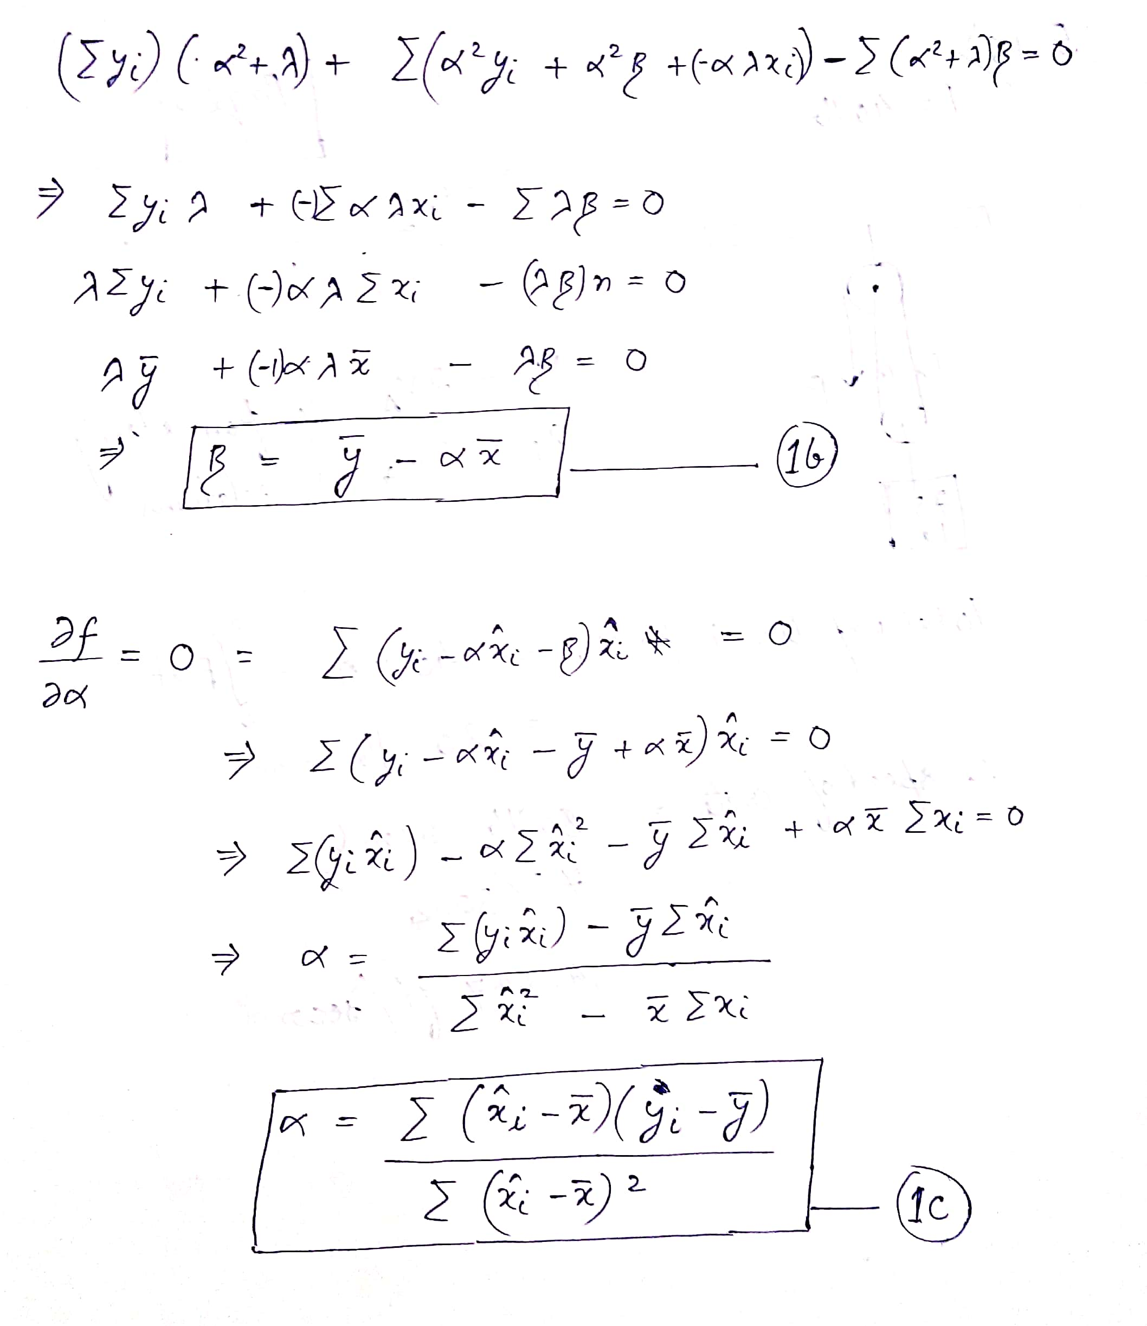

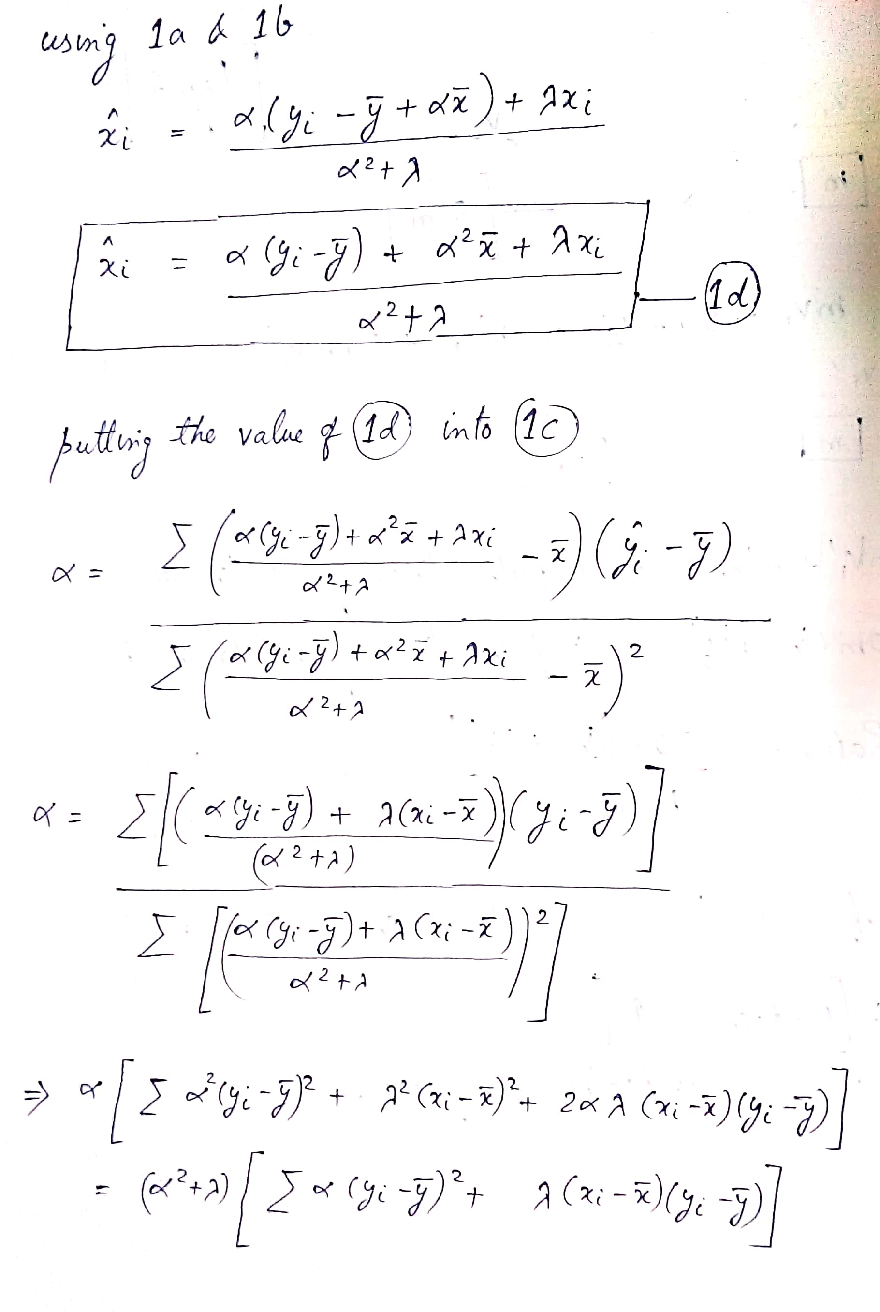

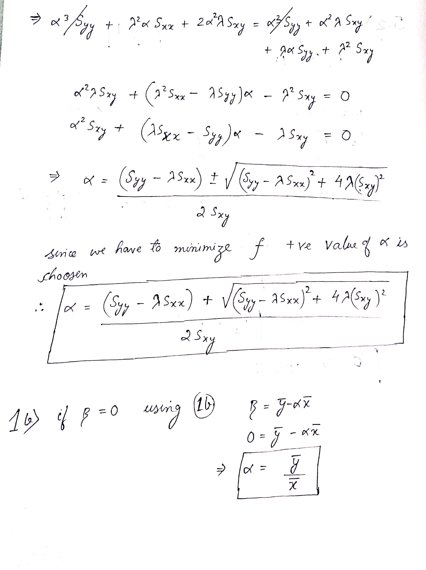

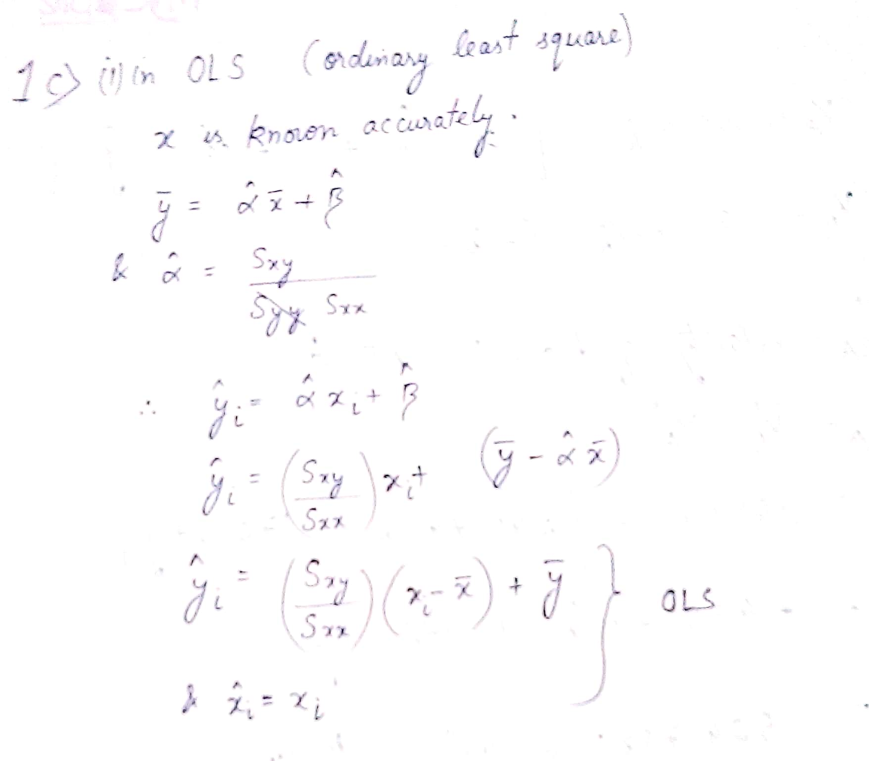

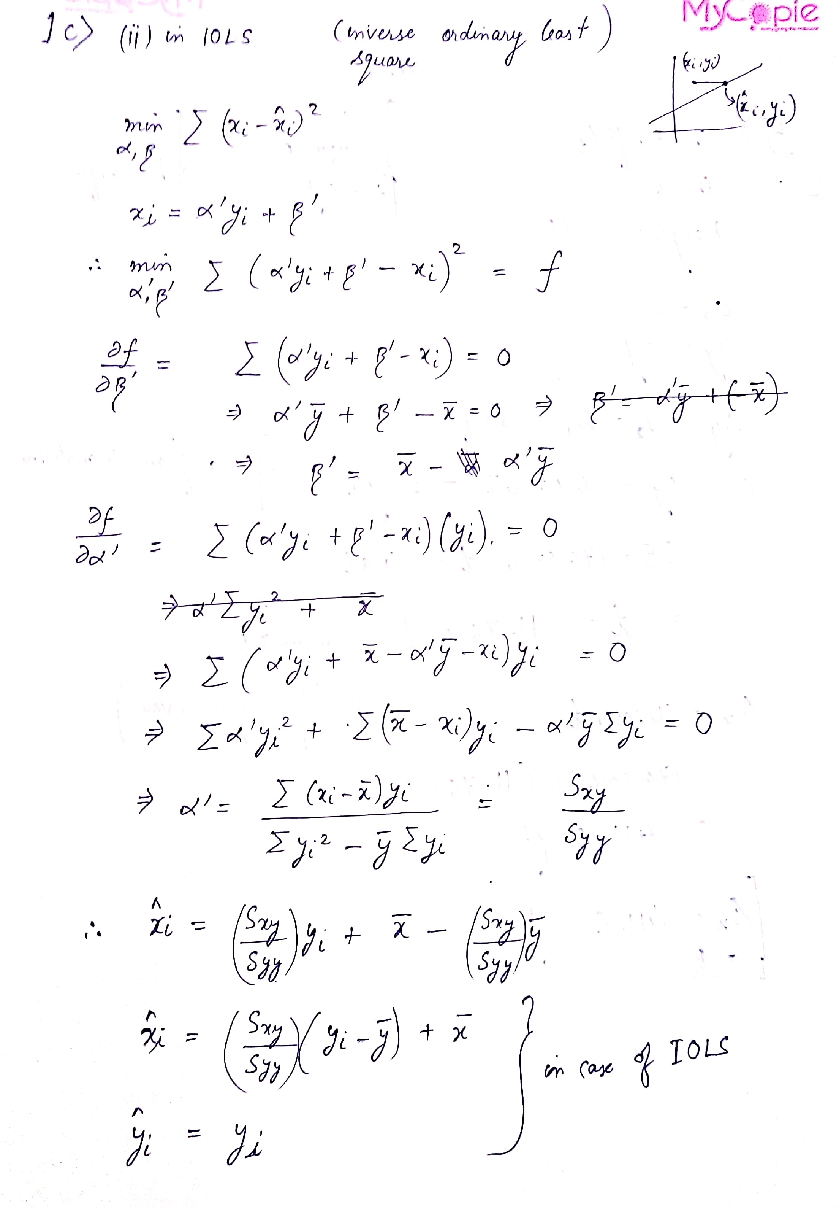

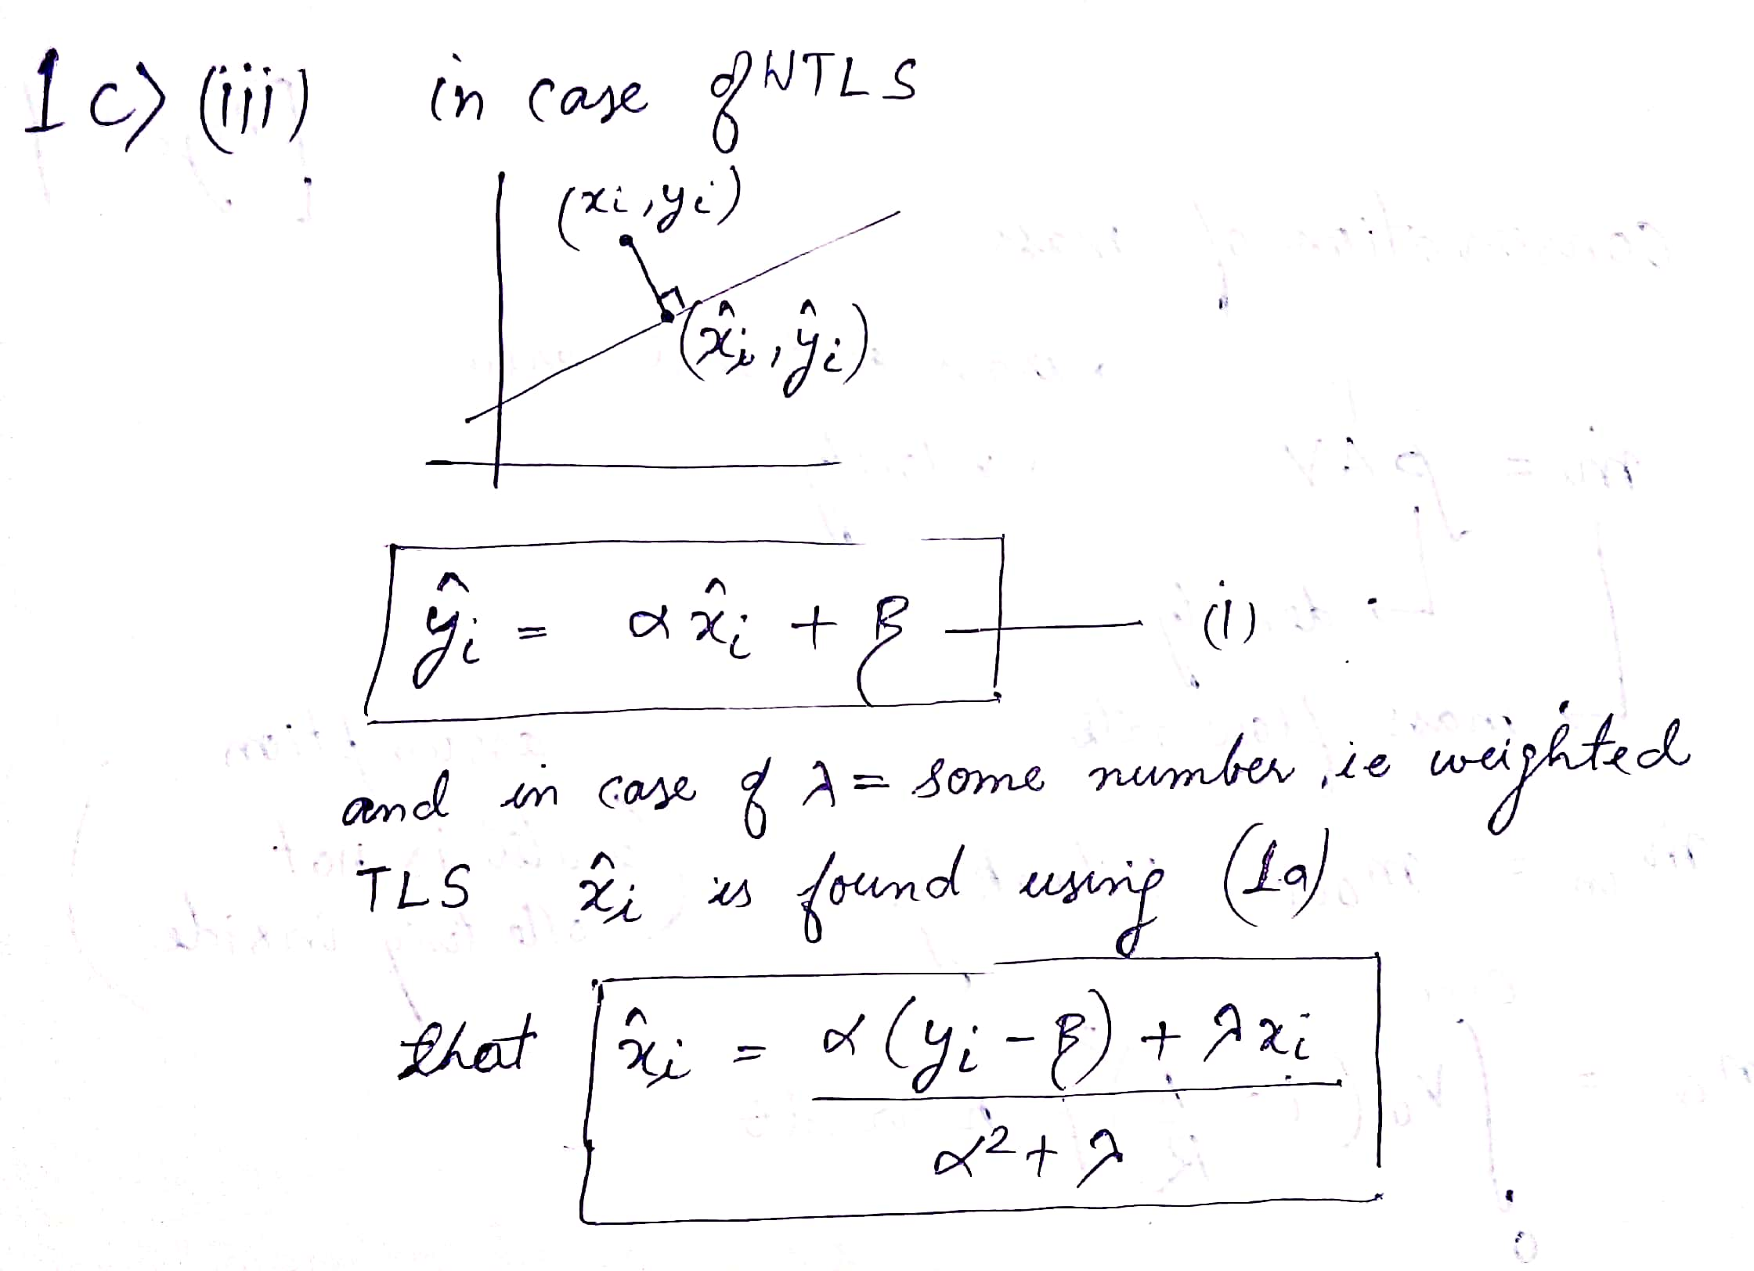

**………………………………………………………………………………………………………………………..**

**Ans 2) a)**Below is the matlab code for calculation of alpha and beta.

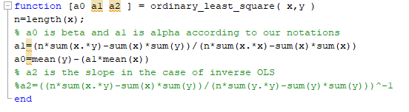

After running the code, and treating the CF method as y and EP as x we get the value of alpha as 0.9924 and the value of beta as -0.0497 and below is the snippet of the result.

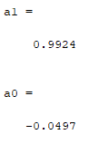

**Ans 2) b)**

Difference between x and y is computed then the mean and the standard deviation is also computed. And z=x-y

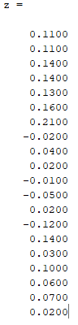

Mean of z= 0.065

Standard deviation of z =0.081

Using this t statistic =3.58

And p value of statistic =0.001

Therefore for 95% confidence = [-2.03 , 2.16]

As the confidence interval contains 0 therefore null hypothesis is not rejected.

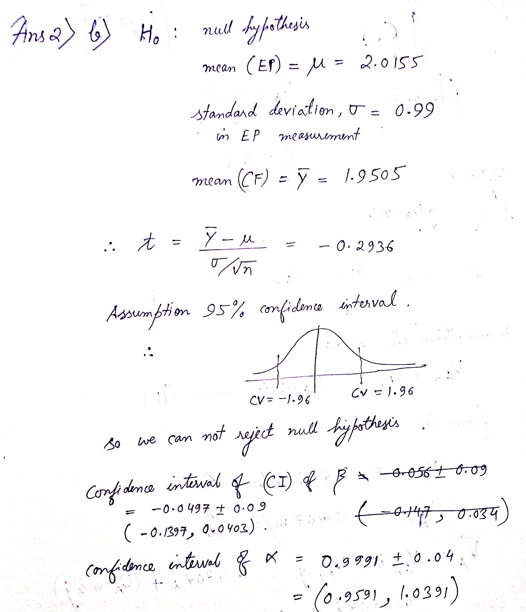

Since null hypothesis cannot be rejected the level of phytic acid is 2.31 mg/l

**………………………………………………………………………………………………………………………**

**Ans 3)**

Here it is given in the question that we have to take minimum value.

Below is the snippet of function written in matlab which returns the slope in case of OLS and IOLS and value of intercept for the case of OLS. Value of alpha in case of OLS is smaller as in the case of IOLS hence we will use OLS.

